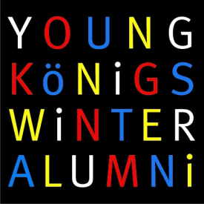
Please return to:

Young Königswinter Alumni e.V.
c/o Steltemeier & Rawe Gmbh
Neustädtische Kirchstr. 6 · D-10117 Berlin
Fax +49 30 27 57 23 38 · board@ykwa.org

Young Königswinter
Alumni e.V.
c/o Steltemeier & Rawe GmbH
Neustädtische Kirchstraße 6 10117 Berlin
Fon +49 30 2 75 72 30
Fax +49 30 27 57 23 38
board@ykwa.org

www.ykwa.org

Vorstand
Dr. Holger Friedrich
(Erster Vorsitzender),
Annegret Kummert
(Stellv. Vorsitzende),
Manuel Kilian
(Schriftführer),
Christiane Lehmann
(Schatzmeisterin)
Dr. Nils Krause,
John Suares
(beide Beisitzer)
Bankverbindung
Young Königswinter
Alumni e.V.
IBAN: DE03 5059 2200 0004 8349 25
BIC: GEN0DE51DRE
Volksbank Dreieich eG

Application for Membership to the Young Königswinter Alumni e.V.

I want to become a member of the Young Königswinter Alumni Verein (YKWA e.V.) and want to receive information on future YKW Alumni activities and events. I have read the Charter of the Young Königswinter Alumni and understood that there is no membership fee.

NAME FIRST NAME

____________________________________________________________

STREET CITY POSTAL CODE

COUNTRY

____________________________________________________________

DATE OF BIRTH PARTICIPATED YOUNG KÖNIGSWINTER
(DD/MM/YYYY) CONFERENCE IN (YEAR)

____________________________________________________________

PHONE E-MAIL

____________________________________________________________

CITY DATE SIGNATURE

___________________________________________________________

